企业中长期战略目标（Medium and long term strategic objectives of enterprises）
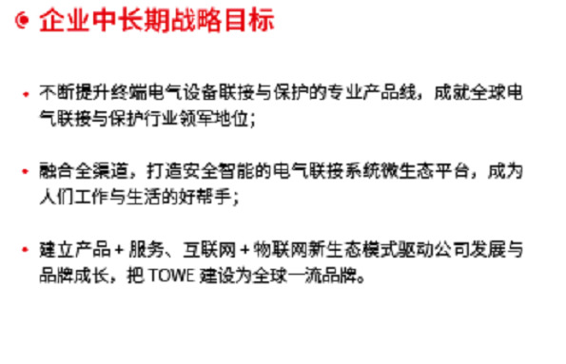
·不断提升终端电气设备联接与保护的专业产品线，成就全球电气联接与保护行业领军地位；
Continuously improve the professional product line of terminal electrical equipment connection and protection, and achieve the leading position in the global electrical connection and protection industry
·融合全渠道，打造安全智能的电气链接系统微生态平台，成为人们工作与生活的好帮手；
Integrate all channels, build a safe and intelligent micro ecological platform of electrical link system, and become a good helper for people's work and life
·建立产品+服务、互联网+物联网新生态模式驱动公司发展与品牌成长，把TOWE建设为全球一流品牌。
To build product + service, Internet plus Internet of things new ecosystem driving the company's development and brand growth, and building TOWE into a world-class brand.

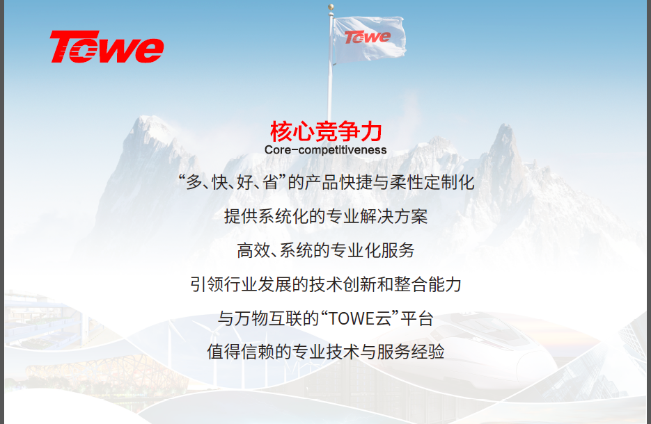

核心竞争力（Core competitiveness of the enterprise）
“多、快、好、省”的产品快捷与柔性定制化
The quick and soft-customization product service of“Lots、quick、well、saving”
提供系统化的专业解决方案
Providing systematic and professional solutions
高效、系统的专业化服务
Effective and systematic professional service
引领行业发展的技术创新和整合能力
Technological innovation and integration ability leading the development of the industry
与万物互联的“TOWE云”平台
The “TOWE-cloud”flat connecting with IoE
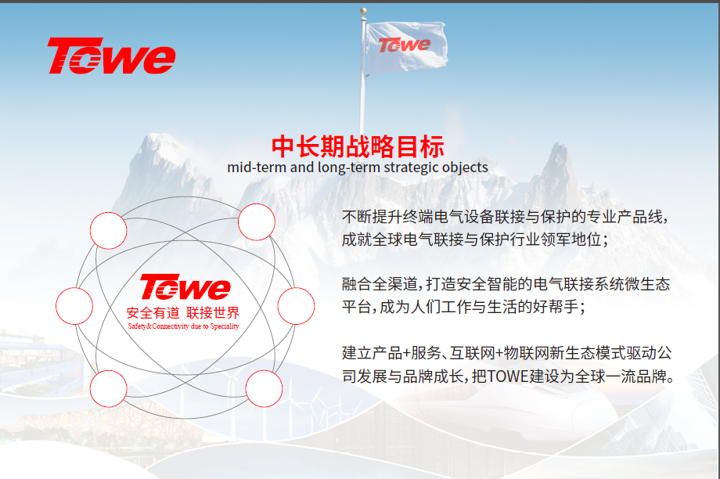
中长期战略目标（Medium and long term strategic objectives）
不断提升终端电气设备联接与保护的专业产品线，成就全球电气联接与保护行业领军地位；
Continuously improve the professional product line of terminal electrical equipment connection and protection, and achieve the leading position in the global electrical connection and protection industry
融合全渠道，打造安全智能的电气链接系统微生态平台，成为人们工作与生活的好帮手；
Integrate all channels, build a safe and intelligent micro ecological platform of electrical link system, and become a good helper for people's work and life
建立产品+服务、互联网+物联网新生态模式驱动公司发展与品牌成长，把TOWE建设为全球一流品牌。
To build product + service, Internet plus Internet of things new ecosystem driving the company's development and brand growth, and building TOWE into a world-class brand.

愿景（Wish ）
让工作、生活更安全、更舒适

Let work、life both become safer and more comfortable

